SIMATS ENGINEERING

ASSESSMENT TOOL 2

COURSE NAME: CSA1613 COURSE CODE: Data Warehousing and Data Mining

COURSE OUTCOME COVERED
CO3: Evaluate the effectiveness of classification techniques on real-time data for accurate prediction, enabling informed decision-making. (BL3,BL4,BL5)
Assessment Tool Weightage: 30%

QUESTIONS: 3 Total Marks:30

Annexure C Case study
Criteria | Understandin g of Case (2.5) | Application of Concepts  (2.5) | Analysi s (2) | Solution Design (2) | Clarity (1) | Total(10  )
Weightag e | 25% | 25% | 20% | 20% | 10% | 100%
Q1
Q2
Q3

Code of Conduct:
I G.Mohammad shareef/(192311288)_ (Name / Reg No) certify that this submission is my original work and that I have adhered to the guidelines specified for this assessment.
I understand that any violation of academic integrity rules will result in disciplinary action.
Signature of the student:G.MOHAMMAD SHAREEF
RUBRICS FOR CALCULATION:
Criteria | Weightag e | Level 4 – Exemplary | Level 3 – Proficient | Level 2 – Developing | Level 1 – Beginning

Understandin g of Case | 25 | Thorough  understanding  ; clearly identifies all key issues | Good  understanding with most issues identified | Basic  understanding  ; some issues missed | Poor  understanding  ; problem not identified  correctly
Application of Concepts | 25 | Effectively applies relevant  concepts to analyze the case deeply | Applies  appropriate concepts with minor gaps | Limited  application of concepts | Fails to apply relevant concepts
Analysis | 20 | In-depth  analysis with strong  reasoning and insights | Good analysis with logical reasoning | Basic analysis with limited depth | Weak or no analysis; lacks  reasoning
Solution Design | 20 | Innovative, feasible  solutions with strong  justification | Logical solutions with adequate  justification | Basic solutions with weak  justification | Incorrect or no solution  provided
Clarity | 10 | Clear,  wellstructured, and easy to  understand | Organized and understandabl e presentation | Limited clarity and structure | Poor clarity; difficult to understand
ANNEXURE A
Case Study:

- A shepherd boy gets bored tending the town's flock. To have some fun he cries out, "Wolf!" even though no wolf is in sight. The villagers run to protect the flock, but then get really mad when they realize the boy was playing a joke on them.
One night, the shepherd boy sees a real wolf approaching the flock and calls out, "Wolf!" The villagers refuse to be fooled again and stay in their houses. The hungry wolf turns the flock into lamb chops. The town goes hungry. Panic ensues. Identify TP,FP,FN,TN

- Assume there are 100 images, 30 of them depict a cat, the rest do not. A machine learning model predicts the occurrence of a cat in 25 of 30 cat images. It also predicts absence of a cat in 50 of the 70 no cat images. Identify TP,FP,FN,TN and Calculate the Precision and Recall and F1 Score .

- An email service provider wants to classify emails as Spam or Not Spam using features:

  - Contains “Offer” (Yes/No)

  - Contains “Free” (Yes/No)
  - Email Length (Short/Long)

Sample Dataset
Offer Free Length |  |  | Class
Yes | Yes | Short | Spam
Yes | No | Long | Not Spam
No | Yes | Short | Spam
No | No | Long | Not Spam
Yes | Yes | Long | Spam
No | No | Short | Not Spam
Questions

- Calculate prior probabilities:
  - P(Spam), P(Not Spam)
- Compute conditional probabilities for each feature.
- Using Naïve Bayes, classify:
  - (Offer=Yes, Free=No, Length=Short)
- Compare results using WEKA (Naïve Bayes classifier).
- Discuss the independence assumption in Naïve Bayes

Confusion Matrix for the Shepherd Boy and Wolf Problem
We can consider:
  - Positive (+) = A wolf is actually present / a "Wolf!" warning is given.
  - Negative (−) = No wolf is present / no "Wolf!" warning is given.

Actual condition = Whether a wolf is really present.
  - Prediction = Whether the boy gives a "Wolf!" warning.

 | Wolf Present (Actual +) | Wolf Absent (Actual −)
"Wolf!" Warning (+) | TP | FP
No "Wolf!" Warning (−) | FN | TN

True Positive (TP):
A real wolf is approaching the flock, and the shepherd boy correctly cries "Wolf!".
  - Actual condition: Wolf is present.
  - Prediction/warning: Wolf is present.
  - The warning is correct. Therefore:
TP = Real wolf + Warning given

False Positive (FP):
There is no wolf, but the shepherd boy cries "Wolf!" as a joke.
  - Actual condition: No wolf.
  - Prediction/warning: Wolf is present.
  - The warning is incorrect. Therefore:
FP = No wolf + False warning
This happens when the villagers run to protect the flock even though there is no danger.

False Negative (FN)
A real wolf is present, but the warning is not recognized or acted upon.
In the story, the boy actually calls "Wolf!" when the real wolf appears, but the villagers ignore the warning because of his previous false alarms.

For the classification interpretation, this represents a missed detection:
  - Actual condition: Wolf is present.
  - Effective prediction/action: No warning response.
  - The real danger is missed. Therefore:
FN = Real wolf + Danger missed

True Negative (TN):
There is no wolf, and the boy does not give a false "Wolf!" warning.
  - Actual condition: No wolf.
  - Prediction: No wolf.
  - The decision is correct. Therefore:
TN = No wolf + No warning

Final Answer:

Term | Meaning in this problem
TP | Wolf is present and the warning correctly identifies it
FP | No wolf is present, but the boy falsely cries "Wolf!"
FN | Wolf is present, but the danger is missed/not effectively detected
TN | No wolf is present and no false warning is given

Confusion Matrix, Precision, Recall and F1 Score
Given:
  - Total images = 100
  - Images with cats = 30
  - Images without cats = 70

  - Model correctly predicts a cat in 25 of the 30 cat images
  - Model correctly predicts no cat in 50 of the 70 non-cat images
  - 1: Identify TP, FN, TN, and FP:

True Positive (TP):
The image actually contains a cat, and the model correctly predicts a cat.
TP = 25

False Negative (FN):
The image actually contains a cat, but the model predicts no cat. There are 30 cat images, and 25 were correctly identified:
FN = 30 − 25 = 5

True Negative (TN):
The image does not contain a cat, and the model correctly predicts no cat.
TN = 50

False Positive (FP):
The image does not contain a cat, but the model predicts that there is a cat. There are 70 non-cat images, and 50 were correctly identified:
FP = 70 − 50 = 20

Confusion Matrix:

 | Actual Cat | Actual No Cat
Predicted Cat | TP = 25 | FP = 20
Predicted No Cat | FN = 5 | TN = 50
So:
  - TP = 25
  - FP = 20
  - FN = 5
  - TN = 50

Step 2: Calculate Precision:
Precision tells us how many of the images predicted as cats were actually cats.
Formula:
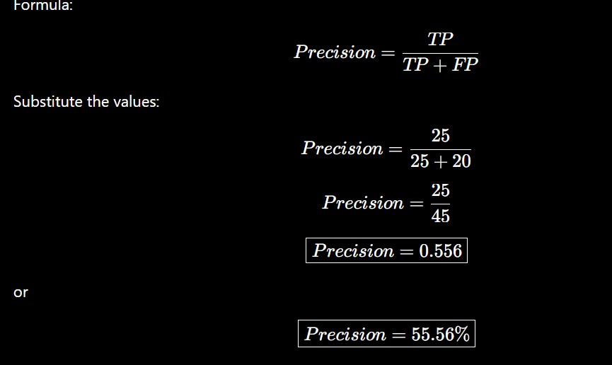
\

Step 3: Calculate Recall:

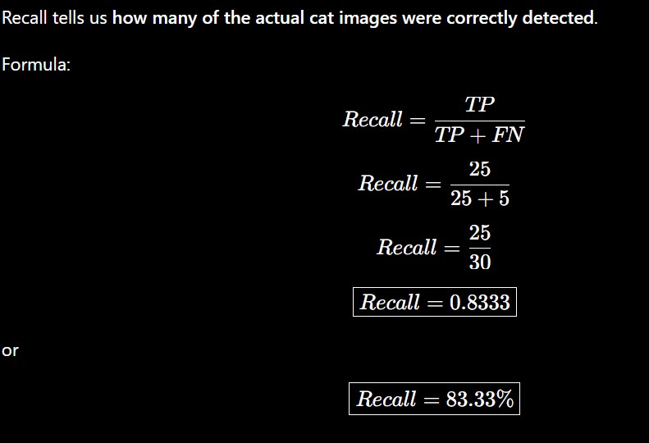

Step 4: Calculate F1 Score:
F1 Score is the harmonic mean of Precision and Recall.
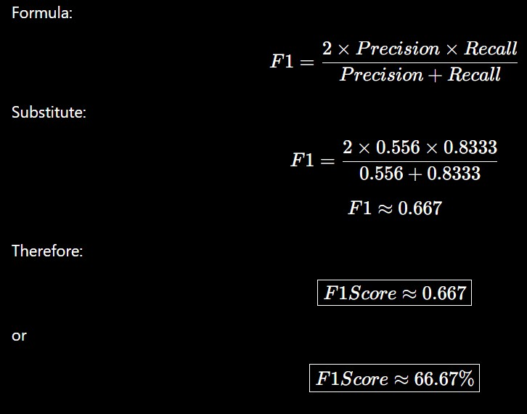

Final Answer:

Measure | Value
TP | 25
FP | 20
FN | 5
TN | 50
Precision | 55.56%
Recall | 83.33%
F1 Score | 66.67%

Conclusion:
The model has a high recall (83.33%), meaning it detects most of the actual cat images, but its precision is lower (55.56%), meaning many of its cat predictions are incorrect.

Offer | Free | Length | Class
Yes | Yes | Short | Spam
Yes | No | Long | Not Spam
No | Yes | Short | Spam
No | No | Long | Not Spam
Yes | Yes | Long | Spam
No | No | Short | Not Spam

3.Naïve Bayes Classification – Spam Email

Given Dataset

Total emails = 6
  - Spam = 3
  - Not Spam = 3

Calculate Prior Probabilities:
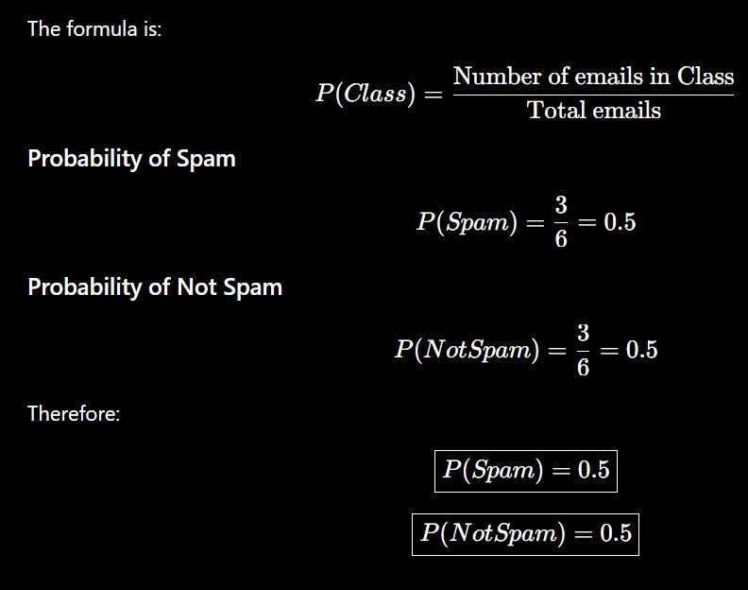

Calculate Conditional Probabilities
We need to calculate the probability of each feature value given the class.

Feature: Offer For Spam
There are 3 Spam emails:
  - Offer = Yes → 2
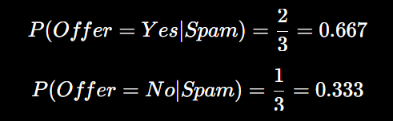
  - Offer = No → 1 Therefore:

For Not Spam
There are 3 Not Spam emails:
  - Offer = Yes → 1
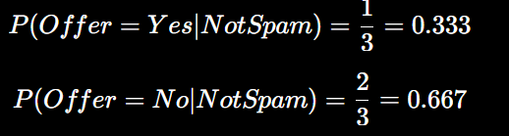
  - Offer = No → 2 Therefore:

Feature: Free For Spam:
Among the 3 Spam emails:
  - Free = Yes → 2
  - Free = No → 1 Therefore:
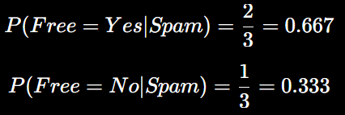

For Not Spam:
Among the 3 Not Spam emails:
  - Free = Yes → 0
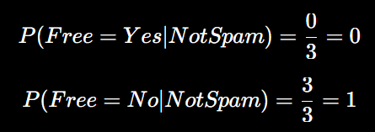
  - Free = No → 3 Therefore:

Feature: Length For Spam
Among the 3 Spam emails:
  - Short → 2
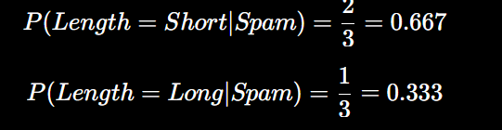
  - Long → 1 Therefore:

For Not Spam
Among the 3 Not Spam emails:
  - Short → 1
  - Long → 2

Therefore:
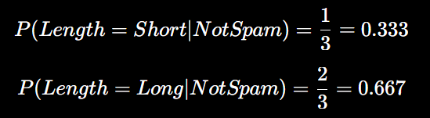

Conditional Probability Table:

Feature | Spam | Not Spam
P(Offer=Yes) | 2/3 | 1/3
P(Offer=No) | 1/3 | 2/3
P(Free=Yes) | 2/3 | 0
P(Free=No) | 1/3 | 1
P(Length=Short) | 2/3 | 1/3
P(Length=Long) | 1/3

Therefore:


Conditional Probability Table:

Feature | Spam | Not Spam
P(Offer=Yes) | 2/3 | 1/3
P(Offer=No) | 1/3 | 2/3
P(Free=Yes) | 2/3 | 0
P(Free=No) | 1/3 | 1
P(Length=Short) | 2/3 | 1/3
P(Length=Long) | 1/3 | 2/3

- Classify (Offer=Yes, Free=No, Length=Short)
We need to calculate the probability that the email is Spam and Not Spam. The Naïve Bayes formula is:

Probability of Spam
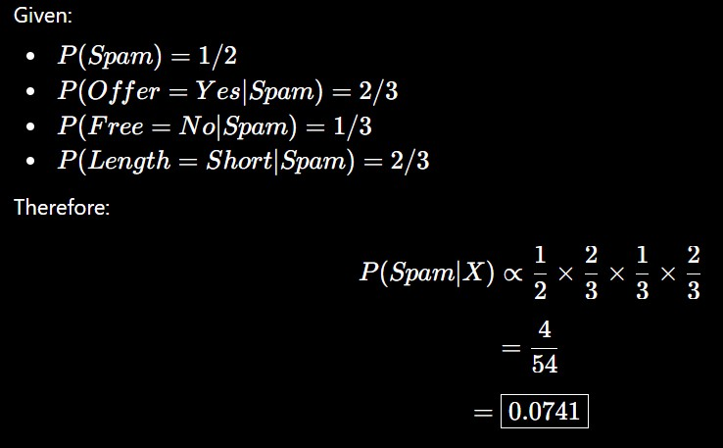

Probability of Not Spam:
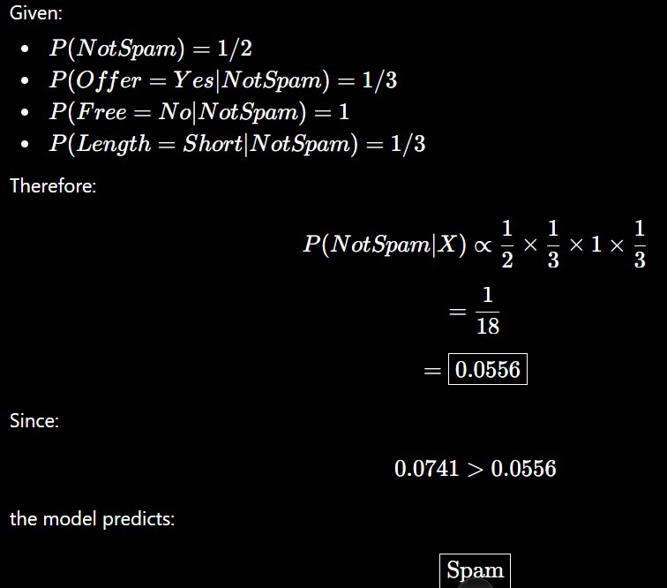

Normalized probabilities:
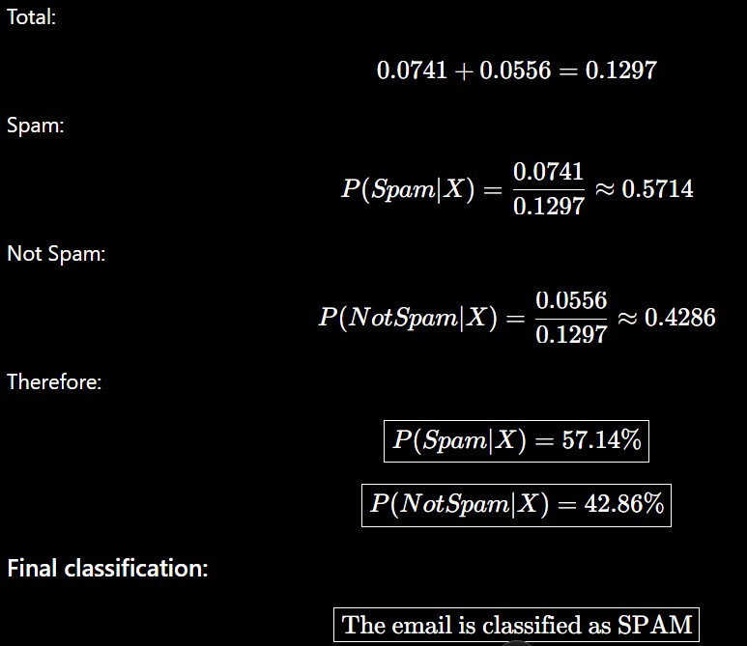

Compare Results Using WEKA
In WEKA, the same dataset can be entered into an ARFF file and the NaiveBayes classifier can be selected.

Expected WEKA result
For:
Offer = Yes, Free = No, Length = Short
the Naïve Bayes classifier should classify the email as:

Spam
Our manual calculation also gives:
Spam = 57.14%
Not Spam = 42.86%
Therefore, the manual result and WEKA classification should agree, assuming the same dataset and settings are used.

Note: Because this is a very small dataset, WEKA's exact displayed probabilities can differ slightly depending on its probability estimation/smoothing settings.
The predicted class should remain Spam for this example.

Independence Assumption in Naïve Bayes
Naïve Bayes assumes that all features are conditionally independent given the class.
For this problem, it assumes that:
  - Offer
  - Free
  - Length
are independent of each other once we know whether the email is Spam or Not Spam.
For example:
is approximated as:
This assumption makes Naïve Bayes simple and fast. Limitation
In real emails, these features may not actually be independent. For example:
  - Emails containing "Free" may frequently also contain "Offer".
  - Email length may be related to the words used in the email.
  - Spam emails may have combinations of features rather than independent features.
Therefore, the independence assumption may not always be completely realistic. However, Naïve Bayes can still perform well even when the independence assumption is not perfectly true.

Final Answers:

Question | Answer
P(Spam) | 0.5 (50%)
P(Not Spam) | 0.5 (50%)
TP/Conditional probabilities | Calculated above
Spam score for given email | 0.0741
Not Spam score | 0.0556
Normalized Spam probability | 57.14%
Normalized Not Spam probability | 42.86%
Final classification | SPAM
WEKA result | SPAM
Independence assumption | Features are assumed conditionally independent given the class

